This is the Title: Apply the Style called “PaperTitle.”
Keep as One Paragraph; Use Line Breaks (Shift–Enter)
to Create New Lines
Author1, author2, and author3: Apply the style called “author.”

ABSTRACT: Apply the style called “heading1.”

Note that one figure or table may be included with your abstract. An appropriate caption is required as well. Please follow the formatting guidelines below.
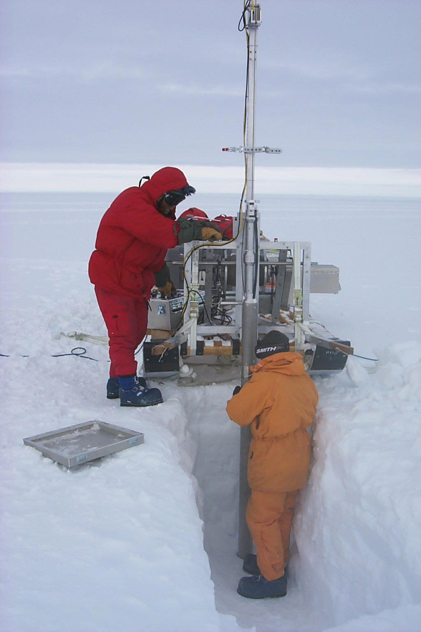
Apply the style called “Figure.”
Figures and Graphs: Center Justify: Times New Roman 9 pt font, Spacing: 12 pt before 0 pt after. (color accepted)Figure caption: apply the style called “Figure Caption.” Center Justify: Note: Times New Roman 9 pt font, spacing 6 pt before and 12 pt after.
Table 1. Apply the style called “TableTitle.” Center Justify, 9 pt Times New Roman, Bold, Spacing 12 pt before and 6 pt after. Avoid vertical separator lines and use powers of 10 for very large or small numbers.
Percent of hydrometric stations
 | Item A | Item B | Item C  (units) | Item D  × 10^{x} (units) | Item E | Item F | Item G range (units)
Location or Case I (units) | - | 22.0 | 33.3 | 4.44 | 55.5 | 6.66 | 0 - 0.9
Location or Case II (units) | - | 22.0 | 33.3 | 4.44 | 55.5 | 6.66 | 0 - 0.9

General procedure for changing the style of your document: It is highly recommended that you start your document from this template (or copy and paste text from previous document), so that you avoid potential problems with applying styles. Please save your document as a .docx named by “your last name_ESCYear”. For example, a submission for the conference of 2023 would be “Smith_ESC23.docx”.

First author’s affiliation and address. Apply style called “footnote text”
Second author’s affiliation and address.
Third author’s affiliation and address.

